 THE TIMES OF INDIA 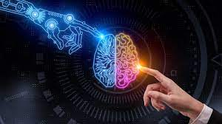

# Everything you need to know about AI in 2023

# 

## How is AI going to change the job market?

Technology’s impact on productivity growth has been consistently overstated in the past, writes Boston Consulting Group for the Forum. Are analysts making the same mistake with generative AI?

Apparently so. Technological progress over recent decades has failed to lift growth rates in advanced economies such as the US because technology is only part of the picture – productivity growth needs to occur to see the real economic benefits.

## How is AI going to reshape the global economy?

[Technology’s impact on productivity growth has been consistently overstated in the past](https://www.weforum.org/agenda/2023/08/generative-ai-realistic-economic-impact/), writes Boston Consulting Group for the Forum. Are analysts making the same mistake with generative AI?

Apparently so. Technological progress over recent decades has failed to lift growth rates in advanced economies such as the US because technology is only part of the picture – productivity growth needs to occur to see the real economic benefits

## How is AI transforming the health sector?

Pandemics, a surge in chronic diseases, mental health concerns and an ageing population – the healthcare industry is facing multiple challenges alongside rising demand for high-quality healthcare.

However, AI and machine-learning technologies are already being used in areas from the development of drugs and vaccines to improving medical diagnosis and treatment, boosting efficiencies across the overall healthcare system.

The Forum’s Saemoon Yoon and Amara Amadiegwu asked [six industry experts how they see AI and machine learning changing global health outcomes](https://www.weforum.org/agenda/2023/06/emerging-tech-like-ai-are-poised-to-make-healthcare-more-accurate-accessible-and-sustainable/).

## How is AI eroding trust in the media?

[How can we build trustworthy media ecosystems in the age of AI and declining trust](https://www.weforum.org/agenda/2023/10/news-media-literacy-trust-ai/), asks Minos Bantourakis, Head of Media, Entertainment and Sport Industry at the Forum.

With great difficulty it seems, not least because trust in news media is already low, and declining. Only 40% of the population trust news, while concerns over disinformation are growing, with more than half of the population worried about fake news.

## A Short Story Written Entirely by AI

The boy was not sure what he was doing in the forest. He had been hiking for hours and thought he was at the edge of his endurance. The summer heat and humidity were oppressive and had left him feeling weak. He was seeking peace and quiet, a place to meditate and escape the distractions of his busy life. Maybe he was looking for treasure, but he did not know it. He was annoyed that his cell phone had no signal, but he was even more upset that his GPS had malfunctioned, and he had lost his way.

He thought he should be back at his vehicle by now. Unfortunately, he was not sure where he was, and he was becoming increasingly frustrated. He started to worry that he was lost. He was not worried about being eaten by wild animals. There were none in this part of the forest. He was, however, concerned that the sun would soon set and that he would become disoriented and lost at night.

He was feeling a bit less confident than he usually did when he was on a mountain hike. He had felt more at home in the rugged, beautiful surroundings of the Alps, but he was not sure that he had the endurance to blast his way out of this particular situation. He was happy to traverse the rugged trails of the mountains,but he was not convinced that he could battle his way out of this. He was grateful that he was a healthy man, but he was not sure that he had the strength to hike his way out of the jungle.

***Absci and AstraZeneca forge AI partnership to discover cancer treatments***

a frontrunner in generative AI antibody discovery, has partnered with biopharmaceutical giant [AstraZeneca](https://www.astrazeneca.com/) to leverage AI in the quest for a novel cancer treatment.This collaboration will capitalise on Absci’s [Integrated Drug Creation](https://www.absci.com/technology/) platform—seamlessly integrating with AstraZeneca’s expertise in oncology, aiming to expedite the discovery of a potentially game-changing cancer therapy.



Cricket fans in India can watch the India vs South Africa 2023-24 matches live telecast on the Star Sports Network channels. You can watch the India tour of South Africa live streaming on the Disney+Hotstar app and website.

*[Type a quote from the document or the summary of an interesting point. You can position the text box anywhere in the document. Use the Drawing Tools tab to change the formatting of the pull quote text box.]*

[Type a quote from the document or the summary of an interesting point. You can position the text box anywhere in the document. Use the Drawing Tools tab to change the formatting of the pull quote text box.]

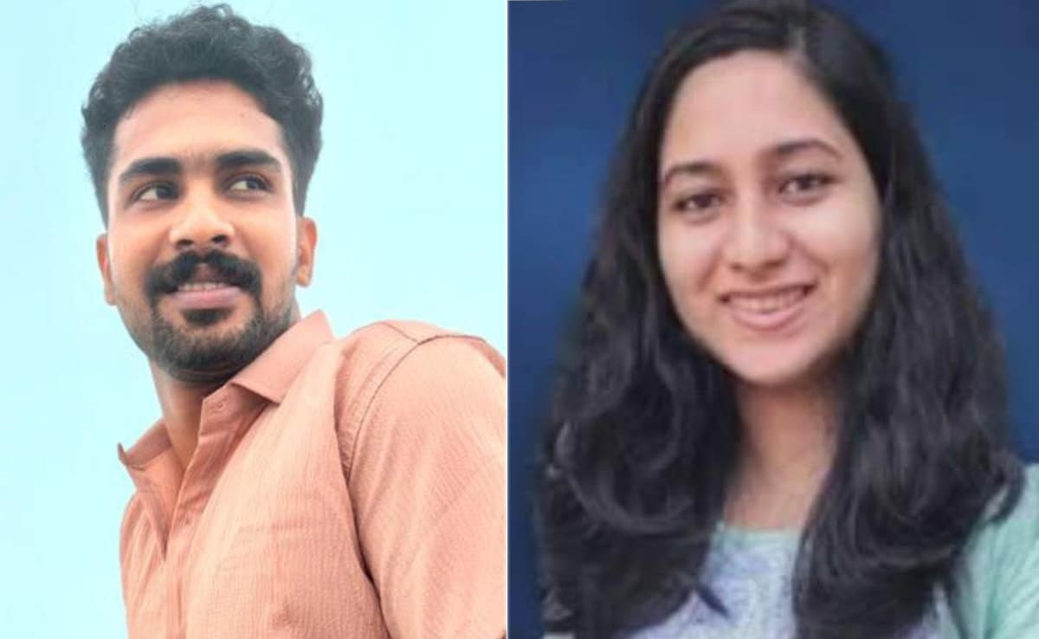

my family cannot provide one and a half kg of gold, acres of land if they ask for the same," Dr Shahana wrote in the purported note. The police recovered the suicide note from the apartment where she was found dead and arrested the accused, PTI reported.

Dr Shahana's family alleged that the accused's family demanded 150 gold sovereigns, 15 acres of land and a BMW car in dowry. When Dr Shahana's family said they could not meet the demand, her boyfriend's family called off the wedding.

**"True That My Family...": Keral Doctor Names Boyfriend In Suicide Note**

Shahana, a 26-year-old doctor in Kerala, died by suicide after her boyfriend allegedly demanded dowry and her family couldn't fulfill her demands. In a suicide note, purportedly written by Dr Shahana, she alleged that her boyfriend Dr EA Ruwais's dowry demands abetted her to die by suicide. "It is true that

